Creating the Dashboard

|  |  |
| --- | --- |
| Team ID | PNT2022TMID22202 |
| Team Lead | Santhosh Kumar V |
| Team Members | Sharan R  Yogesh S  Yuvaganesh GK |
| Project Name | A New Hint to Transportation-Analysis of the NYC Bike Share System |

**Step 1:** Creating a dashboard by clicking on the options button at the top left corner

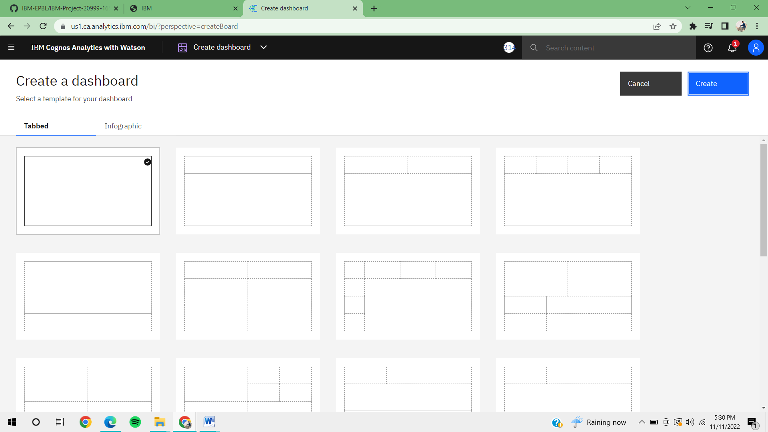

**Step 2:** After Creating a dashboard, add the source file to be visualized uploaded from **My contents.**

